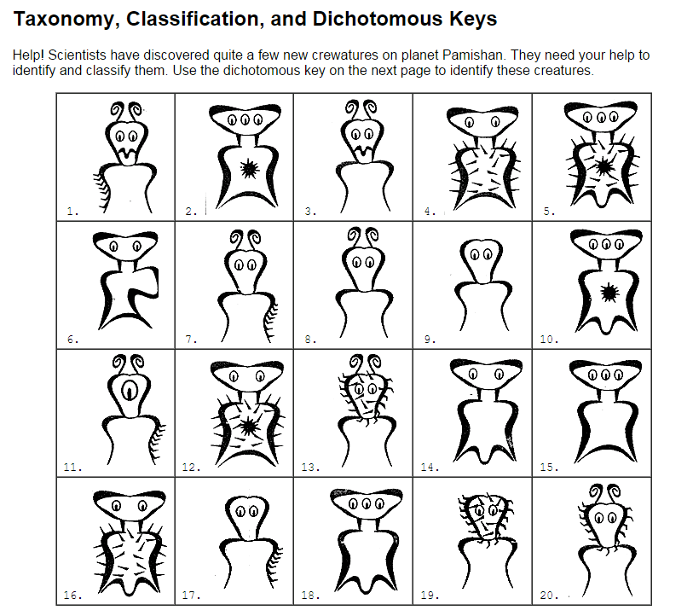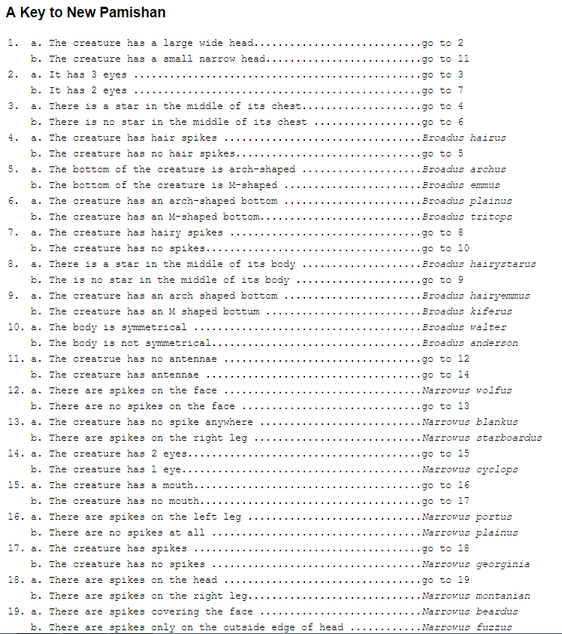

1. ___________________________

2. ___________________________

3. ___________________________

4. ___________________________

5. ___________________________

6. ___________________________

7. ___________________________

8. ___________________________

9. ___________________________

10. ___________________________

11. ___________________________

12. ___________________________

13. ___________________________

14. ___________________________

15. ___________________________

16. ___________________________

17. ___________________________

18. ___________________________

19. ___________________________

20. ___________________________