Protein Synthesis 4 W’s
When? | What? | Who? | Where?
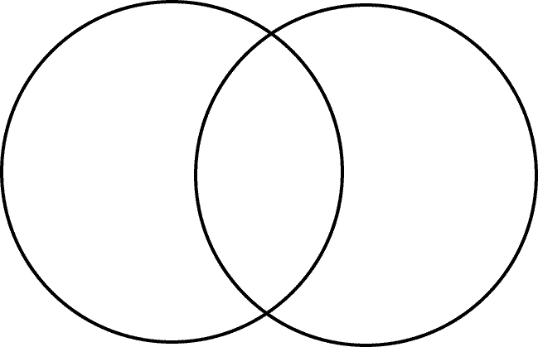
RNA
DNA

