Dichotomous Keys- a chart that uses a series of choice to help you identify organisms
At each step in a dichotomous key you will have 2 choices! (di- means two)
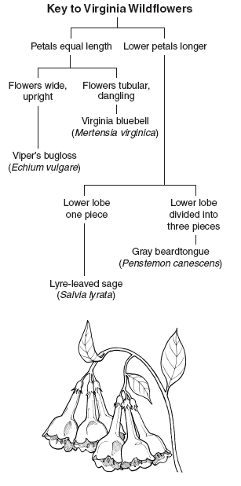

For the Pamishan dichotomous key that I want you to complete #1-10 on you will look at creature #1 and then go to choice one. Whichever statement applies to creature 1 will lead you to the next number or identify the name of that creature. For example: since creature 1 has a small narrow head you would go to #11. Read the choice in #11 and continue until you identify the creature #1. Then look at creature #2 and start back at option 1 again! For each creature you start at option #1.

